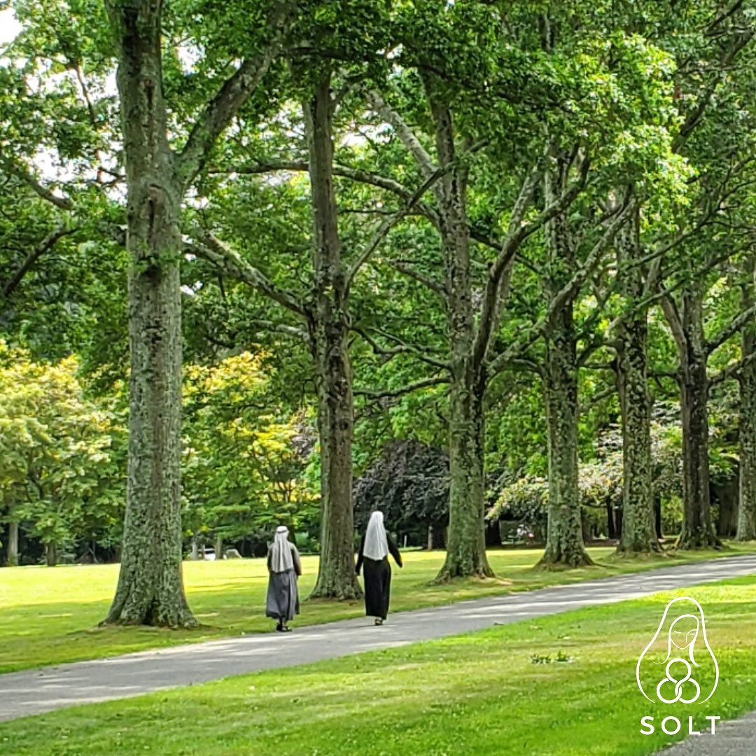

Sunday, March 10 - Lenten Day of Prayer **
Friday, March 15 – Holy Hour for Vocations ***
Friday, April 19 – Holy Hour for Vocations ***
Sunday, April 28 – Spring Musicale *
Friday, May 17 – Holy Hour for Vocations ***
Wednesday, June 12 – Garden Tour & Luncheon *
(visit three Gardens with Lunch at Seminary)

Monday, July 15 – Annual Golf Classic *
Woodside Club, Syosset

